Hazard and Risk Identification in Beaufort, South Carolina
Institution Affiliation
Name
Course

Beaufort South Carolina consists of many islands that are linked to each other by a bridge. Beaufort is located on Port Royal Island in the heart of the Sea Islands and South Carolina Lowcountry. Beaufort, South Carolina has a population of about 13,074, and it is ranked as the 3,190th largest city in America. The state has a population density of 467 per square miters which is said to be 415% higher than that of the national average, and 216% higher than that of South Carolina average (ESRI Business Information Solutions, 2004). The population's medium age of Beaufort is 33, and this value is about 14% lower than that of South Carolina, which is recorded at 39. Among the population inhabiting in Beaufort, South Carolina, 49% of them were born in South Carolina, 45% were born out of the state, 55 were foreign-born, and 15 were born of the United States.
Identification of Hazards and Risks
The state is vulnerable to a number of manmade and natural hazards and risks. The following constitute a list of both manmade and natural hazards are risks: floods, sinkholes, landslides, wildfire, and nuclear facility.
Flooding
Flooding is the most occurring and costly natural hazard within the US. Around three-quarter of the presidential disaster, declarations are linked to flooding within the country. Floods are a potential threat for all areas within the United States of America at any given time within a year. Floods cause a lot of fatalities if they occur (Greenhorne & O'mara, 2004). Floods causes death, damages infrastructures such as houses, and food shortage after it destroys agricultural products in the farms. There is a high possibility of floods occurring within the state since it is located around islands, and it lacks proper maintenance of flood control and drainage systems.
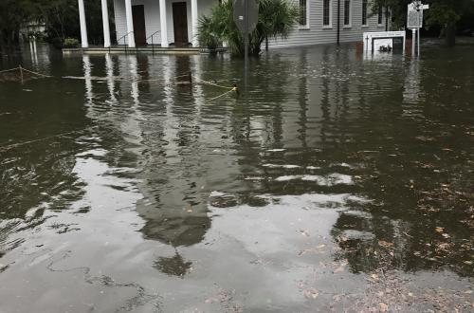
Link: https://www.cakex.org/sites/default/files/styles/swiper_gallery/public/Beaufort%209-11-17_2120.JPG?itok=yQqv37fq
Sinkholes
Sinkholes are a natural geologic feature. Sinkholes are common in areas with salt beds, carbonate rock, and other types of rocks that can dissolve in water. South Carolina, Beaufort does not frequently experience sinkholes. Majority of the sinkholes that occur in South Carolina are human made caused. Some of the manmade activities that are said to be causing sinkholes within the state are water line maintenance and drainage work. Once sinkholes occur, they cause deaths, and damage of properties such as buildings and roads. There have been no significant sinkholes reported within the area (Greenhorne et al., 2004).
Landslides
Landslides are a form of mass wasting whereby a slope collapses leading to mudflow. In most cases, landslides are caused by rain events and erosion. Landslides cause deaths and destruction of infrastructures that are erected within the areas where they occur (Titus, 1995). Also, landslides causes damage of the natural settings of the regions where they occur. The coastal area of the state is prone to landslides although there have been no significant occurrences of landslides reported in the past.
Nuclear Facility
South Carolina houses five nuclear power facilities. Also, some other three nuclear facilities are set up in the neighboring states and pose a threat of affecting people living within the state -South Carolina. Thus, the residents of Beaufort, South Carolina are prone to the consequences that might emanate from the nuclear facilities. The nuclear facilities presents impacts such as contamination of the environment leading to death or some other health issues if they happen to leak. The possibility of a leakage occurring in the nuclear facilities are low (Greenhorne et al., 2004). It is recorded that about one chance in twenty-thousand per annum that there can occur a severe accident in the nuclear plant.
Wildfire
Wildfire occurs when any forest, brush, grass, or any other outdoor fire is not controlled. Wildfire causes deaths of human beings, wild animals, and destruction of the environment, air, and soil pollution. The negligence of the man causes most of the wildfires. Some of the negligent human behavior that can lead to wildfires are fireworks, smoking, and campfires (Greenhorne et al., 2004). Beaufort has experienced about 5,957 incidences of wildfire. The state is moderately vulnerable to wildfires.
.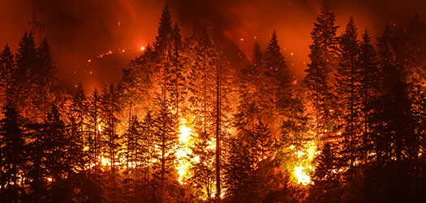
Link: http://sfntoday.com/wp-content/uploads/2018/08/WILDFIRE.jpg

Reference
ESRI Business Information Solutions. (2004). Community sourcebook of county demographics 2006. Place of publication not identified: ESRI Business Information Solutions.
Greenhorne & O'mara, I., & Greenbelt, M. (2004). BEAUFORT COUNTY HAZARD MITIGATION PLAN . Retrieved from: https://beaufortcountysc.gov/archives/county-government/emergency-management/2004-hazardmitigationplan.pdf
Titus, J. G. and V. Narayanan, 1995: The Probability of Sea Level Rise. Washington D.C.: US Environmental Protection Agency, EPA 230-R95-008; http://www.tidesandcurrents.noaa.gov/sltrends/faq.shtml#q1

